FRACTALS-6

**METHODS FOR NONSTATIONARY TIME SERIES ANALYSIS**

**Detrended Fluctuation Analysis (DFA)**

Detrended Fluctuation Analysis (DFA) was introduced by Peng et al. [1] as a method for the quantification of correlations in non stationary time series [2,3,4]. This method represents a modified root-mean-square analysis of a random walk, and was successfully applied in physiological processes [5,6,7], geophysical signals [8,9,10], climatic records [11,12,13], and financial data [14,15,16].

The implementation of DFA algorithm is described as follows:

1. The original temporal series is integrated to produce



where is the average.

1. Next, the integrated series  is divided into  non-overlapping segments of length  and in each segment  the local trend  (linear or higher order polynomial least square fit – DFA1, DFA2, DFA3 ) is estimated and subtracted from . In DFAm, trends of order *m* in the profile  and of order *m −* 1 in the original record are eliminated.
2. The detrended variance is calculated as

.

1. Repeating this calculation for all window sizes provides the relationship between the fluctuation function and window size. If long-term correlations are present in original series,  increases with  according to a power law

.

The scaling exponent  is obtained as the slope of the linear regression of  versus. The value  indicates the absence of correlations (white noise),  indicates persistent long-term correlations meaning that large (small) values are more likely to be followed by large (small) values,  indicates anti-persistent long-term correlations, meaning that large values are more likely to be followed by small values and vice versa. The values  and  correspond to  noise and a Brownian noise (integration of white noise) respectively [1,2].

The DFA analysis has to be based on  values lower than 

The accuracy of DFA exponent α depends on the length *N* of the data. It was shown that statistical standard errors of α (one standard deviation) are approximately 0.1 for N = 500, 0.05 for N = 3 000, and 0.03 for N = 10 000. Findings of long-term correlations with α = 0.6 in data with only 500 points are thus not significant; and α should be at least 0.55 even for data of 10 000 point [18] .

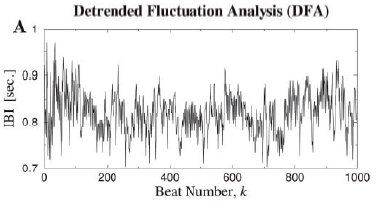

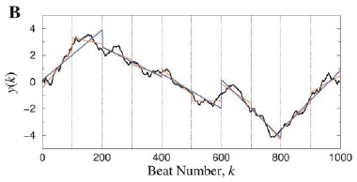

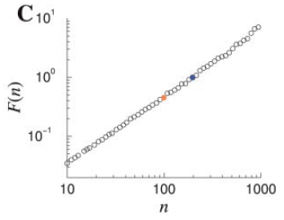

Figure 1. Illustration of DFA algorithm. (A) Interbeat interval time series from a healthy yang adult. (B) Integrated series (solid black curve), linear fit for box size (red straight line segments) and  (blue straight line segments). (C)  versus  plot (Adapted from Ref. [5]).

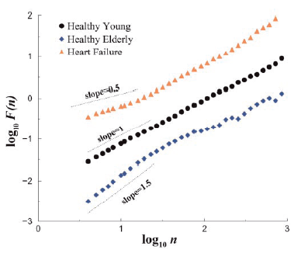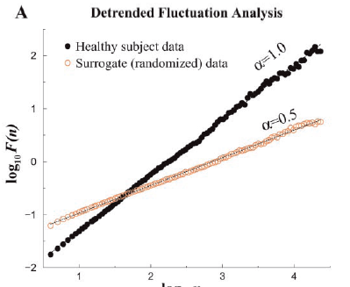

Figure 3. Scaling analysis of heartbeat time series in health, aging, and disease (Adapted from Ref. [5])

Figure 2. Fractal analysis 24-hr Interbeat Interval time series (Adapted from Ref. [5])

The modifications of DFA method based on other detrending approaches were proposed, Detrended moving average method (DMA)[19,20] and Fourrier-detrended fluctuation analysis method [21].

**Detection of Trends and Crossovers with DFA**

Frequently, the correlations of recorded data do not follow the same scaling law for all time scales *s*, but one or sometimes even more crossovers (at time ) between different scaling regimes are observed [17].

*Real crossover*: Crossovers in the scaling behaviour of complex time series can be caused by different regulation mechanisms on fast and slow time scales. Fluctuations of river runoff, for example, show different scaling behaviour on time scales below and above approximately one year.

*Crossover due to short -term correlations*: For short-term correlated data the crossover from  to  appears in double logarithmic plots of the *DFA* fluctuation function (at larger scales all correlations disappear and ).

*Crossover due to trend*: Records from real measurements are often affected by non-stationarities, and in particular by trends. They have to be well distinguished from the intrinsic fluctuations of the system.The fluctuation function  should be calculated for several orders *m* of the fitting polynomial. The crossover will move to larger scales *n* or disappear when *m* is increased, unless it is a real crossover not due to trends (which result in identical slopes α and rather similar crossover positions for all detrending orders *m* [2,3,17]).

**Sign and the magnitude DFA**

To study the origin of long-term fractal correlations in a time series, the series can be split into two parts, which are analyzed separately. The series of increments , is split into a series of signs and a series of magnitudes  [22].

Time series having identical distributions and long-term correlation properties can exhibit quite different temporal organizations of the magnitude and sign sub-series. The DFA method can be applied independently to both of these series.

Most published results report short-term anti-correlations in the sign series i.e.  on low time scales and  asymptotically for large *n*. The magnitude series, on the other hand, are usually either uncorrelated or positively long-term correlated . It has been suggested that findings of are related with nonlinear properties of the data and in particular multifractality [22,23].

REFERENCES

[1] C.-K. Peng, S. V. Buldyrev, S. Havlin, M. Simons, H. E. Stanley, A. L. Goldberger, Mozaic organization of DNA nucleotides, Physical Review E 49, 1685-1689, 1994.

[2] J. W. Kantelhardt, E. Koscielny-Bunde, H.H.A. Rego, S. Havlin, Detecting long-range correlations with detrended fluctuation analysis, Physica A 295, 441-454, 2001.

[3] K. Hu, Z. Chen, P. Ch. Ivanov, P. Carpena, H. E. Stanley, Effect of trends on Detrended fluctuation analysis, Physical Review E 64, 011114, 2001.

[4] Z. Chen, P. Ch. Ivanov, K. Hu, H. E Stanley, Effect of nonstationarities on Detrended fluctuation analysis, Physical Review E 65, 041107, 2002.

[5] A.L. Goldberger, L.A.N. Amaral, J.M. Hausdorff, P.Ch. Ivanov, C.-K. Peng, H.E. Stanley, Fractal dynamics in physiology: Alterations with disease and aging, PNAS 99, 2466-2472, 2002.

[6] R. S. do Nascimento, L. H. G. D. de Araujo, R. B. Moraes, C. T. F. Barbisa, R. C. A, Guedes, R. A. Nogueira, T. Stosic, Analysis of signal fluctuations of cortical spreading depression: Preliminary findings, Physica A 389, 1869-1873, 2010.

### [7] M.  Kirchner, P. Schubert, M. Liebherr, C.T.Haas, Detrended Fluctuation Analysis and Adaptive Fractal Analysis of Stride Time Data in Parkinson's Disease: Stitching Together Short Gait Trials, PLoS ONE 9, e85787, 2014.

[8] [G. Currenti](http://academic.research.microsoft.com/Author/36529111/gilda-currenti), [C. Del Negro](http://academic.research.microsoft.com/Author/13287273/ciro-del-negro), [V. Lapenna](http://academic.research.microsoft.com/Author/18980982/vincenzo-lapenna), [L. Telesca](http://academic.research.microsoft.com/Author/13347291/luciano-telesca), [Fluctuation analysis of the hourly time variability of volcano-magnetic signals recorded at Mt. Etna Volcano, Sicily (Italy)](http://libra.msra.cn/Publication/18566598/fluctuation-analysis-of-the-hourly-time-variability-of-volcano-magnetic-signals-recorded-at-mt), Chaos, Solitons & Fractals 23, 1921-1929, 2005.

[9] Z. Zheng, K. Yamasaki, J. Tenenbaum, B. Podobnik, Y. Tamura, H.E. Stanley, Scaling of seismic memory with earthquake size, Physical Review E 86, 011107, 2012.

[10] R.A. Ribeiro,  M.V. M. Mata, L.S.  Lucena, U.L.  Fulco,  G.  Corso,  Spatial analysis of oil reservoirs using DFA of geophysical data, Nonlinear Processes in Geophysics Discussions 1, 877-893, 2014.

[11] A. Kiraly, I. M. Janosi, Detrended fluctuationa analysis of daily trmperature records : Geographic dependence over Australia, Meteorology and Atmospheric Physics 88, 119-128, 2005.

[12] M.D.O. Santos, T. Stošić, B.D. Stošić, Long-term correlations in hourly wind speed records in Pernambuco, Brazil. Physica A 391, 1546-1552, 2012.

[13] L. Telesca, J.O. Pierini, B. Scian, Investigating the temporal variation of the scaling behavior in rainfall data measured in central Argentina by means of detrended fluctuation analysis, Physica A 391, 1553-1562, 2012.

[14] W. Li, F. Wang, S. Havlin, H. E. Stanley, Financial factor Influence on scaling and memory of trading volume in stock market, Physical Review E 84, 046112, 2011.

[15] J. Alvarez-Ramirez, J. Alvarez, E. Rodriguez, G. Fernandez-Anaya, Time-varying Hurst exponent for US stock markets, Physica A 387, 6159-6169,2008.

[16] K. Yamasaki , L. Muchnik , [S. Havlin](http://www.pnas.org/search?author1=Shlomo+Havlin&sortspec=date&submit=Submit), A. Bunde , H. E. Stanley, Scaling and memory in volatility return intervals in financial markets , PNAS 102, 9424-9428, 2005.

[17] J.W. Kantelhardt, Fractal and multifractal time series. In Meyers, R. A. (ed.) Encyclopedia of Complexity and Systems Science, vol. LXXX, 3754–3778, Springer, Berlin, 2009.

[18] A. Bashan, R. Bartsch, J. W. Kantelhardt, S. Havlin, Comparison of detrending methods for fluctuation analysis, Physica A 387,5080-5090, 2008.

[19] E. Alessio, A. Carbone, G. Castelli, V. Frappietro, Second-order moving average and scaling of stochastic time series, European Physics Journal B 27, 197-200, 2002.

[20] J. Alvarez-Ramirez, E. Rodriguez, J.C. Echeverrıa, Detrending fluctuation analysis based on moving average filtering, Physica A 354, 199-219, 2005.

[21] C.V. Chianca, A. Ticona, T.J.P. Penna, Fourier-detrended ﬂuctuation analysis, Physica A 357, 447-454, 2005.

[22] Y. Ashkenazy, S. Havlin, P.Ch. Ivanov, C.-K. Peng, V. Schulte-Frohlinde, H.E. Stanley, Magnitude and sign scaling in power-law correlated time series, Physica A 323, 19-41, 2003.

[23] T. Kalisky, Y. Ashkenazy, S. Havlin, Volatility of linear and nonlinear time series, Physical Review E 72, 011913, 2005.